A000-Afr-D R Congo-Commemorative Statue-*phemba*-mid 20th c

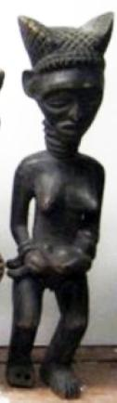

Afr-D R Congo-Commemorative Statue-*phemba*-mid 20th c

Case No.: 6

**Accession No.**

**Formal Label:** Afr-D R Congo-Commemorative Statue-*phemba*-mid 20th c

**Display Description:**

The wood sculptures that represent royal wives have various postures. In this example a woman holds a child as though in presentation. Her face is carefully rendered and she wears a royal hairdo with coral interlaced. This is a commemorative statues known as *phemba* that was designed for women who wanted another child. These carvings, generally sophisticated and very graceful, were thought to favor such a happy event. A maternity statue’s effectiveness depended on the dignity of the figure and its youth (shown by the firmness of the breasts) and the jewelry, which augmented its beauty and status.

**LC Classification:**

**Date or Time Horizon:** mid 20th c

**Geographical Area:** D R Congo

**Map:**

**GPS coordinates:**

**Cultural Affiliation:**

**Media:**

**Dimensions:**

**Weight:**

**Condition:**

**Provenance:**

**Discussion:**

**References:**

Thompson, Robert Farris. 1976. *Black gods anf kings: African art at UCLA*. Bloomington, London: Indiana University Press, ch 12/2, pl. 12.